Creation of volumes in Docker

To create volumes in a docker we have three ways are:

1.Using the Dockerfile

2.Create avolume will create a container using command

3.Creating a local volume and mount it to the container

1.Using Dockerfile

Use a volume with Docker Compose:

The example below shows a single Docker Compose file with a volume.

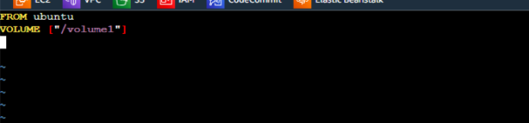

After creating the file execute this command to build the image using that file

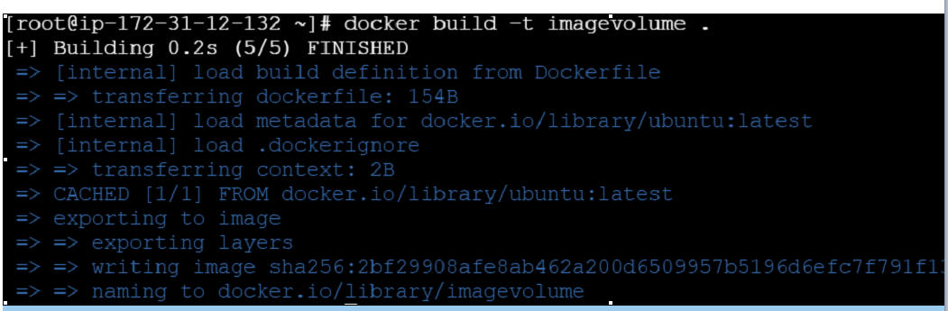

Now create container using the newly created image by execute this command

Docker run –itd –name cont1 –p 80:80 imagevolume



. We have use for docker ps command.The main purpose we have use this command.

“docker ps lists only containers that are currently running. Since your container is not running, it wouldn't appear in the output”.

we have a create a one volume if we want show this volume.we have use this command.

 to connect to the docker volume we have use this command



We have use this “ll” command

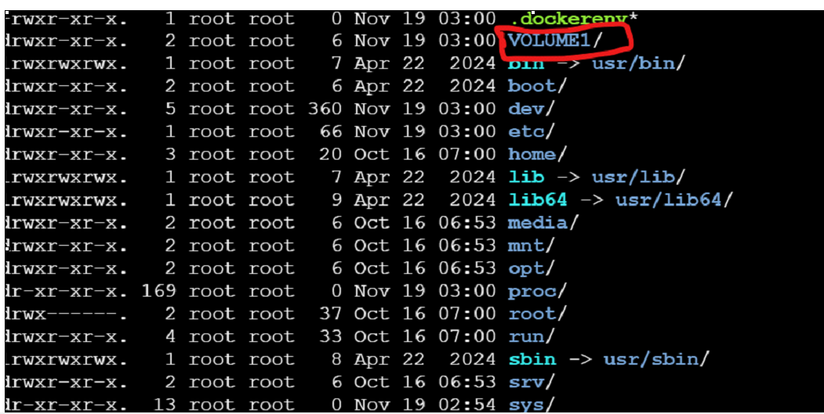

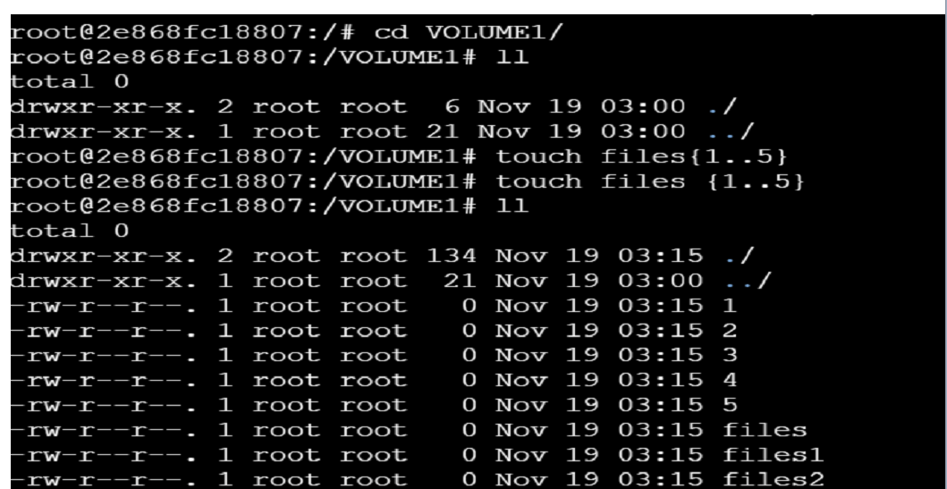Exit from the container

How to share volume one container to another container

We have use privileged command.

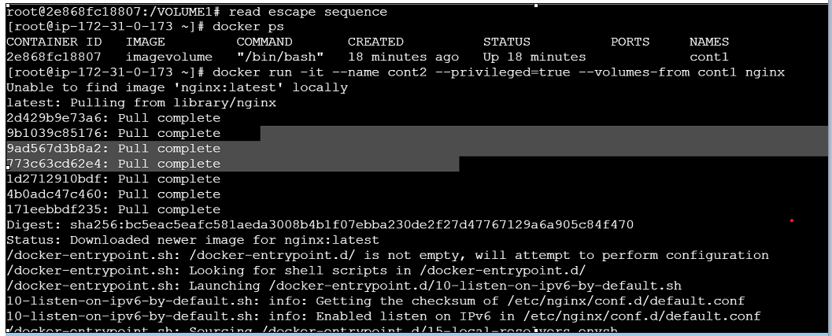Cont2 connect to the docker volum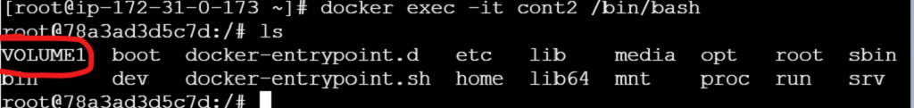

2.Create a volume will create a container using commands:

In these metod we use a simple command to create a volume using any of the required base image

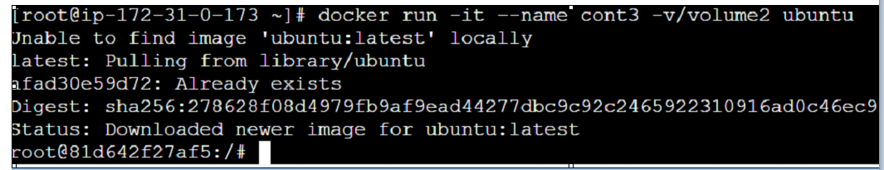

3.Creating a local volume and mount it to the container

In this method first create a local volume using the command

